Delivery of Sprint_1

|  |  |
| --- | --- |
| Team ID | PNT2022TMID50597 |
| Project Name | Smart Waste Management System For Metropolitan Cities |

# CIRCUIT CODE:

#include

<ESP32Se

rvo.h> #include

<LiquidC rystal_I 2C.h>

LiquidCrystal_I2C LCD = LiquidCrystal_I2C(0x27, 16, 2); Servo servo;

i n t

t r i g P

i n 1

= 2

;

digitalWrite(trigPin2, LOW); delayMicroseconds(2); digitalWrite(trigPin2, HIGH); delayMicroseconds(10); digitalWrite(trigPin2, LOW); duration2 = pulseIn(echoPin2, HIGH); distance2= duration2*0.034/2; **Serial**.println("The lid is closed");

}

LCD.setCursor(0,1); LCD.print("Fill Status: ");

if(distance2>300 && distance2<=400){ LCD.setCursor(12,1); LCD.print("25% ");

**Serial**.println("Bin status:25%");

}

else if(distance2 > 200 && distance2<= 299){ LCD.setCursor(12,1);

LCD.print("50%");

**Serial**.println("Bin status:50%");

}

else if(distance2 >50 && distance2<=199){ LCD.setCursor(12,1);

LCD.print("75%");

**Serial**.println("Bin status:75%");

}

else{

LCD.setCursor(12,1); LCD.print("100%");

**Serial**.println("Bin status:100%");

}

if(distance1<=50){ servo.write(90);

}

else{

servo.write(0);

}

}

# CIRCUIT DESIGN:

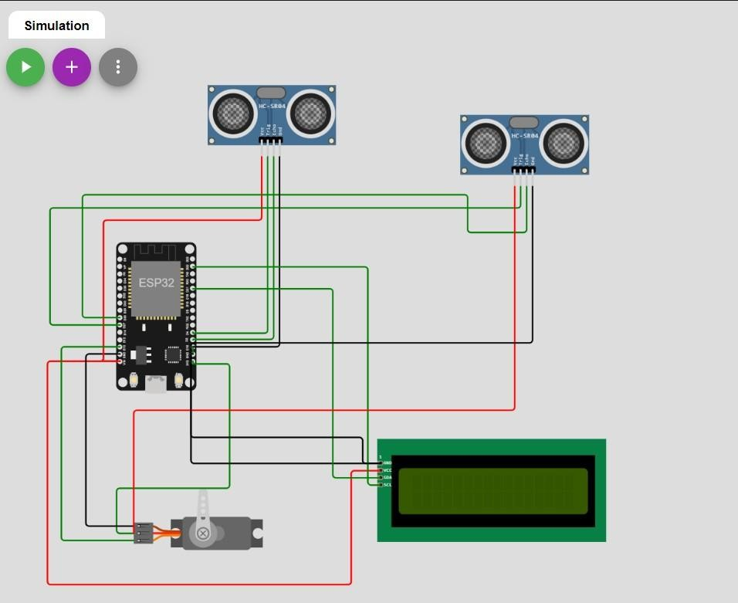

OUTPUT:

